**Homework 1**

R09922063 資工所 鄭筠庭

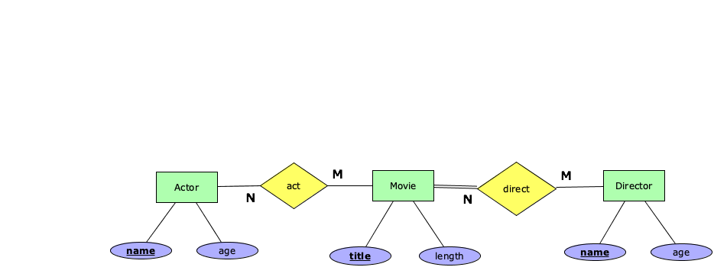**1A.**

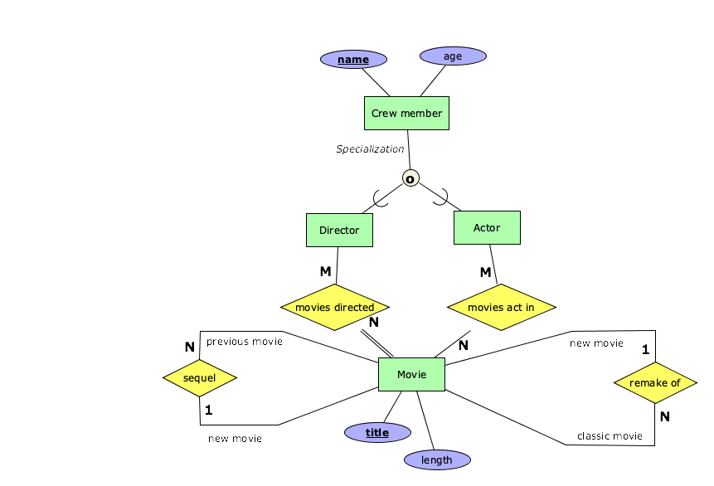**1B.**

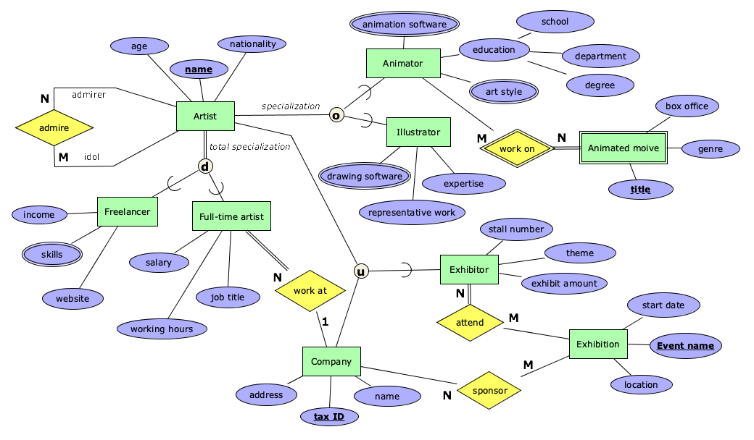**1C.**

**Database name:** **Art Business**

**Entity names:** Artist, Freelancer, Full-time artist, Animator, Illustrator, Exhibitor, Exhibition, Animated movie, Company

**Relationships:** admire, work at, work on, attend, sponsor

**Attributes:**

* Artist {name, age, nationality},
* Freelancer {income, skills, website},
* Full-time artist {salary, job title, working hours},
* Animator {animation software, art style, education {school, department, degree}},
* Illustrator {drawing software, representative work, expertise},
* Exhibitor {stall number, theme, exhibit amount},
* Exhibition {Event name, location, start date},
* Animated movie {title, genre, box office},
* Company {tax ID, name, address}

**Data analysis:**

* “All full-time artist must work at one company.”
* “A Company can have zero or many full-time artists as employees.”
  + “Some artists might admire other artists.”
  + “All the animated movies have at least one animator working on it.”
  + “A movie can have multiple animators working on it, and an animator can have multiple movie projects.”
  + “Some companies will sponsor exhibitions, and an exhibition event can have more than one sponsor.”
  + “All the exhibitors need to attend an exhibition event, while exhibitions may or may not have exhibitors.”
  + “An exhibitor can attend many exhibitions, and an exhibition event can have multiple exhibitors.”